Unit 5 Reporting Results

- Reading Activity

1.1 Pre-reading Task
1. What is the function of the results section?
Key: The function of the results section is to objectively present your key results, without interpretation, in an orderly and logical sequence using both text and illustrative materials (Tables and Figures).

2. What are the major elements included in the results section?
Key: Location of the results; most important findings; comments on the results; generalization from the results and explanation of possible reasons for the results.

3. What are the major steps for you to deal with the results section?
Key:
- Read the literature and review you results;
- Organize your results;
- Prepare figures and/or tables;
- Tell the story of scientific discovery;
- Practice peer review.

4. How do you describe graphic information in the results section?
Key:
--- Introduce the graphic information and make a general statement;
---Describe the graphs with some useful words, phrases or sentence patterns;
---Compare and contrast the data in the graphs;
---Make a conclusion or summary.

5. How do you compare and contrast the data presented in graphs?
Key:
--- Introduce the most significant or important information and compare or contrast it.
---Give stress to those dramatic changes or to those that are of special interest to you, or those that you want your readers to pay more attention to and ignore the less important parts.
---Support the comparison/contrast by concrete and relevant facts or data.
--- Follow the two patterns: the block pattern (or subject-by-subject pattern) & the alternative pattern (or point-by-point pattern) in a comparison and contrast paragraph.

1.3 Reading Comprehension

1.3.1 Key:
Sentences | Elements
Sentence 1 | Review of the research issue
Sentence 2 | Review of the method
Sentence 3 | Review of the method
Sentence 4 | Review of the method

1.3.2 Keys:
1. Our preliminary analysis discovered that…
2. Regarding learner errors, we found…
3. As Table 3 shows,…
4. Descriptive statistics demonstrated that…
5. Results of a one-way analysis of variance (ANOVA) further displayed that…
6. The LSD test showed that…

1.3.3
Key:
Sentences | Function
Last sentence in the 2nd paragraph | Comparison with previous literature or hypothesis
Last sentence in the 3rd paragraph | General statement of the major results

- Language Focus
2.1.1 Key for reference.
The questionnaire survey was related to students’ interest and performance in English class. 82 participants were involved. Of all the subjects, 70 completed and returned the questionnaire form. Question 1 was about the interest in English writing course. A half of the participants surveyed indicated that they were very interested in it. 37.5% agreed that they had interest in the course. Only a small number of respondents felt that they did not have any interest in it. In response to Question 2 concerning the performance in class, most of the respondents (80%) indicated that they were active in group discussion in class. Only 5.7% of those surveyed indicated that they were not active at all in such a classroom activity. It is apparent from the table that the majority of the students liked the English writing course and were willing to participate in group discussion. The overall response to this question was very positive.

2.1.2
Keys：
- a. bottom---in January;
b. peak--- in December
c. fluctuation--- from May to September

- a. In January of 2011, the growth rate of car production was in the bottom of the whole year.
b. It bottomed out at around 1.2% in March 2011. Then, the growth rate rose sharply from 1.2% to nearly 4.5% in April 2011.
c. In the next five months from May to September 2011, there was a fluctuation in the growth rate of car production between 2.8% and 4.6%.
d. It reached a level at 4.1% in October 2011 and then, it increased rapidly in the growth rate of car production and reached the peak at 6.3% in December 2011.

C. The graph shows an upward trend in the growth rate of car production for Ford during the period of January 2011 to December 2011. The graph reveals two important rising periods during the whole year.

2.2.1
Keys:
The tables show averaged scores achieved in the school subjects of Maths, Science, Geography, Languages and Sport by children aged 7, 10, 13, and 15 according to sex.
The subjects for which the highest average scores were recorded were Sport, at 78 (boys), and Languages, at 75 (girls). The strongest subject for each sex was revealed to be the weakest for the opposite sex, with these two subjects also comprising the lowest recorded scores, at 60 and 58 respectively.
Apart from these two subjects, the performance of boys and girls was comparatively similar. Boys tended to score higher in Geography, with scores ranging from 63 to 70, while scores for girls ranged between 62 and 64. However, it is significant that at the age of 15, both boys and girls alike averaged a score of 64 for this subject. The differences between the sexes for scores for Maths and Science were negligible.
It is more interesting to observe the patterns that emerge when the data is examined in terms of age groups. In general, for both boys and girls, children tended to improve as they got older. For boys, between the ages of 7 and 15, improvement can be observed in these ranges of scores: Maths (63-67), Science (70-73), Geography (63-64), and Sport (71-78). For girls, the score ranges can be observed in Maths (64-68), Science (69-72), Geography (62-64), and Languages (62-75). The increase in scores for girls in the last subject, Languages, was the greatest across the different age groups, and its rise from 65 to 75 also constituted the greatest margin between scores for any two particular age groups.
The exceptions to the general trend were Languages, in which scores for boys steadily declined from 62 at the age of 7 to 58 at 15, and Sport, in which scores for girls steadily declined from 65 to 60. The other significant exceptions that emerged were that both boys and girls recorded a slump between particular ages. For girls this happened between the ages of 10 and 13, when scores in Maths fell by 1, Science by 3, and Geography, Languages and Sport by 2. For boys the ages at which this occurred were 13 to 15, when Maths and Languages both fell by 2, Science by 1 and Geography by 6. Boys' scores for sport actually increased by 3 during this period.
To sum up, these tables show that in this study, on average, males performed better in Sport, while females achieved better in Languages. The other significant pattern that emerged from the data was that boys and girls both went through a slump in performance, but this slump happened at different ages for the different sexes.
(Adapted from http://www.ieltschn.com/study/writing/2009-08-20/3692.html)

3.1
Keys：
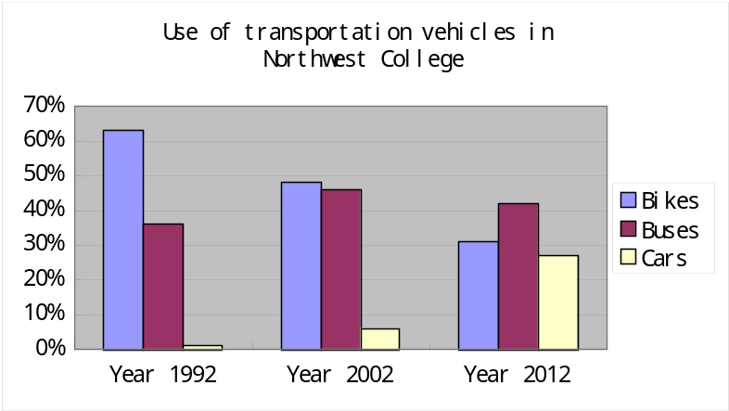

3.2.1.
Keys: B,C,D

3.2.2 Keys for reference:
The line graph below shows the sales amount of an online shop from Monday to Friday. As the graph indicates, the sales amount of the online shop increased slowly from Monday to Tuesday (5732 yuan and 6418 yuan respectively). From the graph we can see that there was a fluctuation in the sales amount. From Wednesday to Thursday, the sales amount dropped drastically from 8967 yuan to 4899 yuan. Actually, on Thursday it was in the bottom of the whole week. But the online shop sold well on Friday and the sales amount reached 9956 yuan, a peak of the whole week. The line graph reveals the change of the sales amount of an online shop from Monday to Friday.

3.3

Questions:

1. What does the table show us?

Key: It shows the teaching language(s) used by English teachers in class.

2. How many teaching languages are mentioned in the table?

Key: Two.

3. What language is used most frequently by English teachers in class?

Key: English.

4. Do English teachers in class often use Chinese?

Key: No.

5. In summary, what impression do you have on the teaching language(s) used by English teachers in class?
Key: English teachers attempt to put their students in an entire English atmosphere, which is good for students’ English learning.

Your description: (for reference)

Table 1 shows the teaching language(s) used by English teachers in class. As Table 1 shows, among the teachers interviewed, 65% of them mainly use English as their teaching language. It indicates that generally speaking, teachers in English classes speak more English than Chinese. They attempt to put their students in an entirely English atmosphere, which is undoubtedly an asset for students’ English learning.

3.4 keys:

Nowadays, personal computers are commonly used among university students in research work or dealing with different documents in and out of class. To choose a suitable personal computer is not easy. You have to consider many factors such as the price and the functions when comparing different types of personal computers. To most university students who have no income, it’s necessary to make a market survey before their purchase of a personal computer.

Table 2 shows the result from a market survey of personal computers. In the survey, three personal computers, PC 1, PC 2 and PC 3, are compared with respect to the following factors: price, processor speed, size of hard disk and screen size. PC 1 costing 2850 yuan, is by far the cheapest of the three and PC 2 is the most expensive. The processor speed of PC 2 is at 3.6 GHz, being 1.6 GHz faster than PC 1 and 0.4 GHz faster than PC 3 respectively. Regarding the size of hard disk, PC 2 has the same hard disk size as PC 3, 500 GB, whereas PC 1 is the smallest at 320 GB. Besides, among the three types of personal computers, PC 2 has the largest screen,15.6". The screen size of PC 1 is 14", which is the same as that of PC 3.

Among the three types of personal computers, PC 1 has the advantage in terms of price while compared with the other two types, it is the slowest in functioning. PC 2 functions best however it’s too expensive for most university students. In general, PC 3 could be a good choice for most university students considering its price and functions.

- Writing Project
Open-ended.

